A Woman’s Place focuses on the people as it navigates tricky times coming out of the pandemic
“We try to provide customized support for whatever the needs are for people at the shelter,” Heldt said. “Sometimes it's working on huge goals like finding employment and finding housing. And sometimes it's working on smaller things like getting a pair of glasses replaced or getting a pair of steel-toed boots to start work.”

A Woman’s Place focuses on the people as it navigates tricky times coming out of the pandemic

Domestic Violence is an act of violence or threatened act of violence by a current or past intimate partner. An intimate partner is a boyfriend or girlfriend, husband or wife, or spouse. (Photo Illustration/Jim Rydbom, Staff Photographer)
By CHRIS BOLIN | cbolin@greeleytribune.com
PUBLISHED: October 28, 2023 at 5:00 p.m. | UPDATED: October 28, 2023 at 5:43 p.m.
A notecard with six simple words hangs on a bulletin board in Diane Heldt’s office.
Handwritten by a local domestic violence survivor after a recent stay, it reads, “A Woman’s Place saved my life.”
“That’s why we do what we do,” Heldt said. “That’s my motivation.”

Heldt is the executive director for A Woman’s Place, the only domestic violence shelter in Weld County. A Woman’s Place provides several resources to survivors of domestic violence, including help finding housing and employment among a laundry list of other things.

“A Woman’s Place provides support and advocacy for survivors of domestic violence and their children,” Heldt said. “Typically, people stay with us about a month. We have a safe shelter, we help them make a safety plan and work on their long term success.”

In the United States, an average of 24 people per minute are victims of rape, physical violence or stalking by an intimate partner, according to the Domestic Violence hotline. Women ages 18 to 34 are generally the most impacted by intimate partner violence.

In Colorado alone, domestic violence-related incidents claimed 94 lives in 2022 – the most recorded in any year. It also marks the second straight year Colorado hit a new high.

“Unfortunately domestic and sexual violence are very common, “said Beth Collins, the domestic violence program director for the Colorado Department of Human Services. “It’s a widespread, epidemic problem.”

A Woman’s Place tries to help survivors of that problem however it can but the majority of the calls they receive are from people seeking emergency shelter, Heldt said. The rest of the support they provide generally falls into four main categories: legal advocacy, housing advocacy, employment support and support for children.

Legal advocacy is pretty self-explanatory – its providing help and support to people navigating an often confusing legal system.

Housing advocacy focuses on finding safe and affordable housing, which is often difficult in a state where the price of housing is soaring.

“In Colorado, we know affordable housing is challenging,” Collins said. “That’s true for many people in Colorado whether or not they’re surviving domestic violence.”

Employment support involves finding survivors jobs and making sure they have everything they need to be successful in those position.

“A lot of people may be working when they come to the safehouse but are unable to stay at their job because it’s unsafe,” Heldt said.

Support for children may be the most encompassing category, especially since every situation requires unique help.

A Woman’s Place makes sure kids don’t fall behind in school while they are staying with their guardian at the safehouse. It also assists in getting them connected with and enrolled in schools in the area in which they are planning on staying moving forward.

But, Heldt says, no request is too big or two small, it all just depends on the survivor’s needs, which the survivor knows better than anybody else.

“We try to provide customized support for whatever the needs are for people at the shelter,” Heldt said. “Sometimes it’s working on huge goals like finding employment and finding housing. And sometimes it’s working on smaller things like getting a pair of glasses replaced or getting a pair of steel-toed boots to start work.
“We work with clients where they’re at, so they tell us what their goals are, and we try to support their goals and work with them to help meet their goals.”
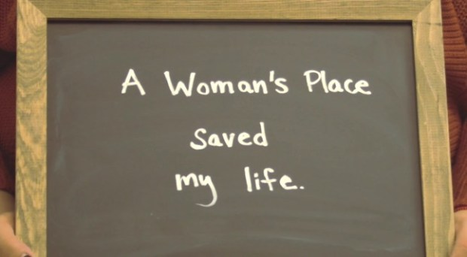
A domestic violence survivor holds up a sign for a picture after receiving support from A Woman’s Place, the only domestic violence shelter in Weld County. A Woman’s Place is celebrating 45 years of empowering domestic violence survivors. (Courtesy/ Executive Director Diane Heldt)

How they navigated the pandemic
During the COVID-19 pandemic, domestic violence shelters around the country were forced to do more with less. A Woman’s Place was no exception.
Social distancing requirements and COVID outbreaks forced many shelters to reduce capacity and even close temporarily. It also trapped many survivors at home with their abusers.
“As people became ill with COVID, it just magnified the challenges for clients who are trying to navigate safety and independence,” Collins said. “Organizations needed to adopt protocols for the safety of clients and staff, so organizations reduced how many folks were able to come into emergency shelter at one time to comply with social distancing standards.”
The pandemic reduced the number of calls shelters across the state received — primarily at the height of lockdown restrictions, but also throughout the pandemic as a whole. Collins said the total number of survivors served by organizations dropped by about 25% in both 2020 and 2021.
“There definitely was a decrease where folks were just staying home, trying to make do as best as they could,” Collins said. “They weren’t reaching out and were more isolated.”
A Woman’s Place experienced exactly the opposite. In 2020, the shelter received twice as many calls in April of that year as they did in any month in 2019. The shelter hit maximum capacity, and they had to turn 82 people away that month.
“Our crisis calls doubled during the pandemic, especially that first year,” Heldt said. “There were a lot of people in crisis reaching out.”
She noted not only the number of calls increased, but also the severity, which is one of the many reasons Heldt is grateful A Women’s Place was able to keep their safe house open throughout the pandemic.
“That was rare for a lot of domestic violence agencies,” Heldt said. “They had to close because of COVID outbreaks. We were very fortunate that we had procedures in place to keep everyone safe and to keep the safe house open during the whole time.”
Heldt also considers the shelter lucky for the community support it received during the pandemic. While funding from some grants dropped, other organizations stepped up to fill in the gaps.
She also praised the way the community rallied behind the organizations that needed help the most.
“One of the strongest parts from my perspective was just that the community came together to support one another, and the nonprofits came together to support each other,” Heldt said.

Awareness
Though community support is huge for “A Women’s Place,” it is far from a one-way street.
Along with the services it provides for survivors at its safe house, A Woman’s Place puts on about 100 presentations on domestic violence and teen dating to local high schools and community groups each year.
“I think as a nation, it is less taboo to talk about domestic violence than it was 10 years ago,” Heldt said. “So we’ve been invited into a lot more places to talk about domestic violence.
“We’re very fortunate that Weld County is supportive and willing to learn and understands domestic violence and the need for supporting survivors.”
Collins echoed Heldt’s sentiment, noting that along with more public awareness, lawmakers had substantial discussions about domestic violence during legislative sessions last year.
“It does seem like there is more conversation in the public about how this issue is impacting Coloradans,” Collins said. “We know this is an important topic for many people throughout the state who are involved in supporting intervention efforts.”
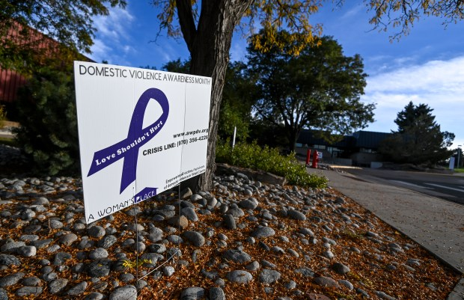A yard sign from A Woman’s Place showing resources for domestic violence victims and survivors for Domestic Violence Awareness Month is seen outside the Westview building at Aims Community College in Greeley Oct. 7, 2021.

What to do?
The signs of abuse vary in every situation, but early warning signs of an abuser include extreme jealousy, controlling behavior and unpredictable mood swings.
A more complete list can be found on A Woman’s Place’s website, awpdv.org, or the National Domestic Violence Hotline’s website, thehotline.org.
Since every situation is so unique, both Heldt and Collins say there is no singular correct way to handle the situation if someone suspects a loved one is experiencing domestic violence. But it is important to offer victims support without giving advice.
Letting victims know that no one deserves to be scared or controlled and that they are not to blame for the actions of others can help, Collins said. It is also important to let them know that you respect their strength and want to support their ongoing safety.
Ultimately, both stress the importance of getting victims connected with people who have specialized training.
“We can say we care and we want to help, that we are concerned,” Collins said. “But it’s also important recognizing that we as helpers are not going to have solutions. So connecting people we care about to confidential victim advocates at community-based organizations can be very helpful.”
For survivors in and around Greeley, that is A Woman’s Place. Where at the root of everything, it’s about the people.
“We can talk about COVID and about funding,” Heldt said. “But the gist of it is really just every day, every week, we’re serving people. We’re helping them be safe and helping them move on.”

Resources
A Woman’s Place:
• www.awpdv.org
• Call: (970) 356-4226
The National Domestic Violence Hotline:
• www.thehotline.org
• Call: 1 (800) 799-SAFE (7233)
• Text: ‘START’ to 88788
Both the Colorado Domestic Violence Program, cdhs.colorado.gov/dvp, and Violence Free Colorado, www.violencefreecolorado.org, offer comprehensive online lists of local organizations across the state.

